**Short note on activity diagram:**

**Activity Diagram - Short Notes**

1. **Definition**:
   * An **Activity Diagram** is a behavioral UML diagram that represents the flow of activities (workflow) in a system.
2. **Purpose**:
   * Used to model **business processes**, **system workflows**, and **sequential operations**.
   * Helps in understanding the **execution flow** of an application.
3. **Symbols & Components**:
   * **Start Node (Initial State)** – Represented by a filled black circle (⚫).
   * **Action/Activity** – Denoted by a rectangle with rounded edges.
   * **Decision Node** – A diamond (◆) that represents branching conditions.
   * **Merge Node** – A diamond (◆) where different branches merge back.
   * **Fork & Join** – Fork (split parallel tasks) & Join (merge parallel tasks) are represented by a thick bar.
   * **End Node (Final State)** – Represented by a black circle with an outer ring (⭕).
   * **Arrows** – Show the flow of execution.
4. **Steps to Draw**:
   * Identify **process flow** or **use case** to be represented.
   * Add **start node**, then actions/decisions.
   * Use **arrows** to define the flow.
   * Include **end node** to indicate completion.
5. **Applications**:
   * Used in **software development**, **business process modeling**, **system workflows**, and **algorithm design**.
6. **Example**:
   * Representing a **login process**, **order processing**, or **ATM transaction workflow**.

This is a concise and easy-to-remember format for exams! 😊

Elements of the activity diagram

**Elements of an Activity Diagram**

1. **Initial State (Start Node)**
   * Represented by a **filled black circle (⚫)**.
   * Indicates where the process begins.
2. **Final State (End Node)**
   * Represented by a **black circle with an outer ring (⭕)**.
   * Marks the completion of the process.
3. **Action/Activity**
   * Represented by a **rounded rectangle**.
   * Denotes a specific task or operation in the workflow.
4. **Transitions (Flow Arrows)**
   * **Arrows (→)** that show the sequence of steps.
   * Connect different actions and decision points.
5. **Decisions (Branching Node)**
   * Represented by a **diamond (◆)**.
   * Used for **conditional flow** (e.g., Yes/No, True/False).
6. **Synchronization (Fork and Join Nodes)**
   * **Fork**: A thick bar that splits a process into parallel tasks.
   * **Join**: A thick bar that merges parallel tasks back into one.
7. **Swimlanes**
   * Vertical or horizontal **partitions** that divide the diagram.
   * Used to show responsibilities of different **actors or departments**.
8. **Objects & Object Flows**
   * Objects: Represented by **rectangles** with names.
   * Object Flow: **Dashed arrows** showing how data moves between actions.

This simple breakdown makes it easier to remember for exams! 😊

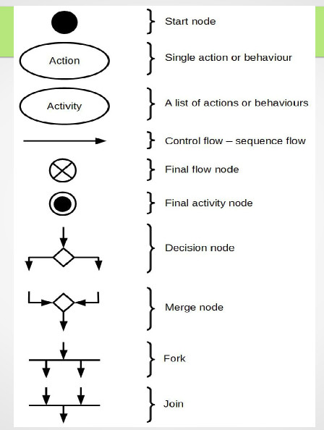

**Guidelines for Designing an Activity Diagram**

1. **Identify the Process**
   * Clearly define the **workflow, process, or use case** to be represented.
2. **Start with the Initial State**
   * Use a **filled black circle (⚫)** to indicate the starting point of the activity.
3. **Use Actions/Activities Properly**
   * Represent each **step or task** in the process using **rounded rectangles**.
   * Ensure that actions are **clear and sequential**.
4. **Define Transitions Clearly**
   * Use **arrows (→)** to indicate the **flow of control** between activities.
   * Ensure that transitions are **logical and connected properly**.
5. **Use Decision Nodes for Conditional Flows**
   * Represent **decision points** using a **diamond (◆)** shape.
   * Label the outgoing paths with **conditions (e.g., Yes/No, True/False)**.
6. **Use Fork and Join for Parallel Processes**
   * Use **fork bars** to **split** processes into parallel activities.
   * Use **join bars** to **merge** multiple parallel activities back into one.
7. **Organize Using Swimlanes** (If Needed)
   * Divide the diagram into **swimlanes** to represent different **roles, departments, or entities**.
8. **Ensure Proper Object Flows**
   * If objects are involved, use **rectangles** to represent them and **dashed arrows** for object flow.
9. **End with a Final State**
   * Use a **black circle with an outer ring (⭕)** to indicate the end of the activity.
10. **Keep It Simple & Readable**

* Avoid unnecessary elements and **maintain a clear layout**.
* Use **consistent symbols** and **avoid crossing lines** to enhance readability.

Following these guidelines ensures a **well-structured and easy-to-understand** activity diagram! 😊

● MCA Admission Procedure 1.DTE advertises the date of MCA ntrance Examination. 2.Students has to apply for the entrance examination 3.Result are declared by DTE. 4.Student has to fill up the option form to select the college of his/her choice. 5.DTE displays the allotment list in the web site and intimation to all colleges. 6.Students should report the allotted colleges and complete the admission procedure

